NHS ART CLUB

The North High School Art club is an organization that provides additional enrichment opportunities of the fine arts to North High School students, while also increasing leadership skills, gains to self awareness, and developing an understanding of personal responsibility to community developments in the arts. We will try to provide opportunities for self importance of personal contributions to cultural awareness, community development, and community enrichment for the promotion of the arts.

Activities include:
- Meeting with former NHS art alumni and other visiting artists who share their portfolios and art professions
- Red Ribbon Week Banner - Design and Painting
- Pumpkin decorating contest - Faculty auction (money to NHS Art Club)
- Christmas Card Sale Fundraiser
- Community service projects
- Art club t-shirt design
- Taste of North
- Preparations for the spring NHS District Art Show
- Cocoa and Canvas Fundraiser
Eligibility:
Open to all students whether or not they take art classes. Students become members by signing up in the fall with Mrs. Swader, Ms. Bretz, or Mr. Hunt. Dues are $10.00 per year.

Meets:
- Art Club will meet about once a month. Meetings will be posted in each art classroom and in the school bulletin in advance of each meeting/event.

Time Commitment:
Approximately one hour per month for meetings plus time to attend events the NHS Art Club is a participant in, September - May.

Sponsors:
Mrs. Swader, Ms. Bretz, Mr. Hunt

Monthly Meeting Calendar
September:
- Sign up for Art Club! Pay $10 dues – give money to Mrs. Swader (D118), Mr. Hunt (D128), or Ms. Bretz (D117).
- Fall Taste of North: Item(s) for sale TBD

October:
- Red Ribbon Week Sheet Decoration to hang in school
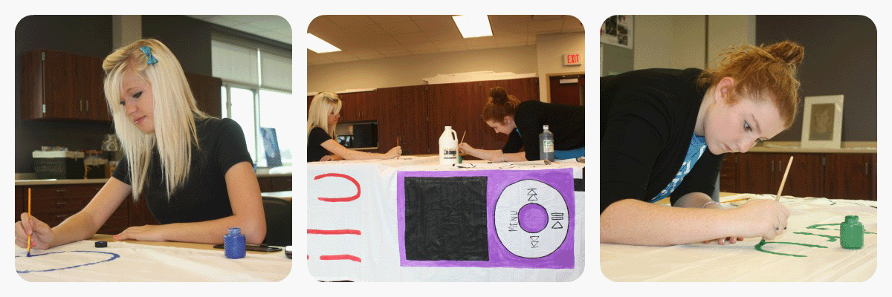
- Decorate, sculpt, or alter a pumpkin for the annual Pumpkin Decorating Contest. Create your work at home and bring the completed project to the October meeting for judging. Participants may work as an individual or as a group. Awards will be provided for the best individual and best group. No more than three participants per group. The pumpkins will be auctioned to the faculty with proceeds going back to the NHS Art Club.

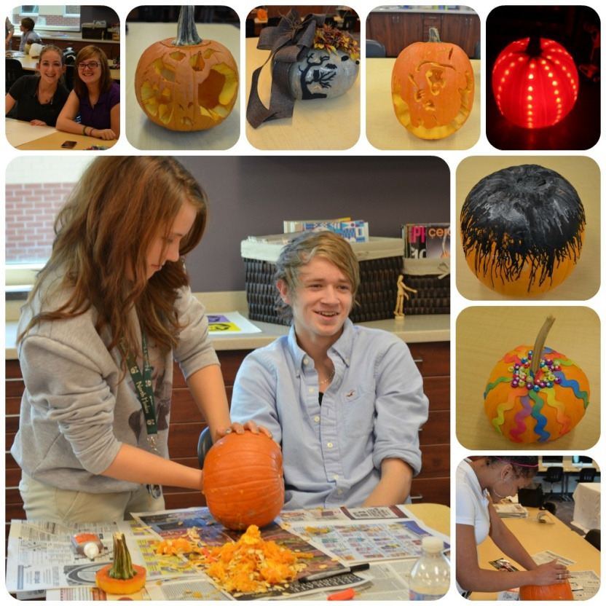
November:
- Sell Christmas Cards as fundraiser!
- Art Club t-shirt design contest: Entries must be submitted by November Art Club meeting and will be voted on by Art Club members. Winning design will be made into a t-shirt for sale to all members!
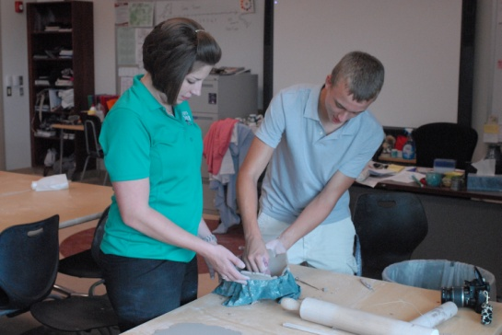
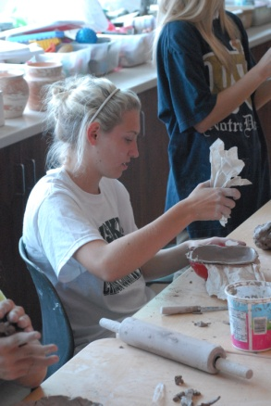
- Community Service Project: Empty Bowls Project with USI Ceramics Department to help raise money for a donation to the local food pantry.
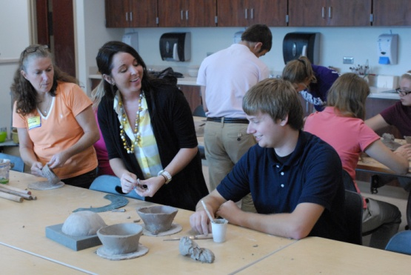
December:
- Community Service Project: Help local businesses by decorating their windows/store displays for the holidays.

January:
- Winter Taste of North: Art Club students will help sell student made ceramic bowls, prints, paintings, and drawings!

February:
- Cocoa and Canvas Fundraiser: Art Club members, in a partnership with a NHS Senior student who is completing her Senior Project, will host a “Cocoa and Canvas” night. This will be an opportunity for teachers, students, and community members to be a part of a guided painting party experience! Hot chocolate and light snacks will be provided as well as all painting materials.

March:
- Possible field trip to visit art museum? (TBD – dependent on fundraising efforts)

April:
- NHS District Art Show Prep

May:
- End of school year party/idea generation for next year’s Art Club events

