Directions:
- Choose one image/portrait in this packet and using the prompts below evaluate what they what the drawings/paintings reveal about the personalities, achievements, and life experiences of the individuals on a piece of paper. Make sure to identify which portrait you are analyzing.
- Think about how these portraits use unconventional composition and how body language and adornment express personality and identity. Also explore cultural ornamentation in analyzing clothing and adornments of various cultures and time periods.

Facial Expression
What do the eyes and mouth reveal about the person/people in the painting?

Pose
What does the position of the body reveal about person/people?

Gesture
What do the hands, feet, arms, or legs reveal about the person/people?

Clothing
What type of clothing is each person wearing (dressy, casual, work clothes)?
What does the clothing reveal about the person/people in the painting?

Point of View
Where was the artist standing when he, she painted this?
What do you see that makes you say that?
Environment
What do all the things around the person reveal? (setting, background, props)
What is the location for the portrait?
Why do you think the artist included certain objects in the painting?
What does the location of objects say about their importance?
What time period do you think is being shown?

Feelings
What is the person feeling? What do you see that makes you say that?
If there is more than one person in the portrait, what are the relationships between the people?
What are the relationships between the artist and the sitter?
What do you see that makes you say that?

Elements of Art
How does each element of art – color, line, shape, texture, space, value – contribute to the artist’s message about the person in the portrait?

Paul Gauguin
Portrait of the Artist with the Idol, ca. 1893
Like many artists, the Post- Impressionist Paul Gauguin painted or sketched himself many times in this three-quarter view, but with varying light sources. His expression with a knitted brow and chin resting in an awkwardly drawn right hand show him as thoughtful and stern. Gauguin often included an object from his surroundings in his self-portraits. During his first trip to Tahiti, Gauguin studied ancient Polynesian deities with the help of his Tahitian companion, Tehamana. The figure behind the artist is the goddess Hina, a symbol of calm and peace. While Gauguin's clothing suggests a colder climate, the figure in the painting may be a reference to his first trip to Tahiti in 1891. In August of 1893, Gauguin returned to France.

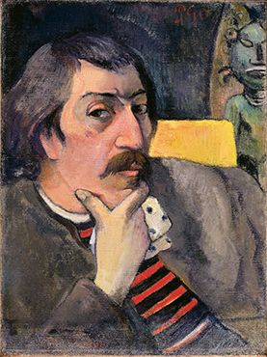

Pablo Picasso
Woman with Plumed Hat, 1901
Wearing heavy make-up and a hat with a flower or feather, Picasso's woman arches her eyebrow at the 19-year-old artist who is painting her. Her face and earrings contrast with the surrounding black hair and blue background. Following the tragic suicide of a close friend early in 1901, Picasso began to paint social outcasts and the poor with cool blue tones, embarking on what came to be called his Blue Period (1901–1904). Considered an early experiment with the monochromatic palette and firm line of the melancholy Blue Period, the woman in this painting bears a resemblance to the figure in Woman in Blue of the same year. By 1905, Picasso moved on to painting less austere subjects in pinks and grays, a period called his Rose Period.
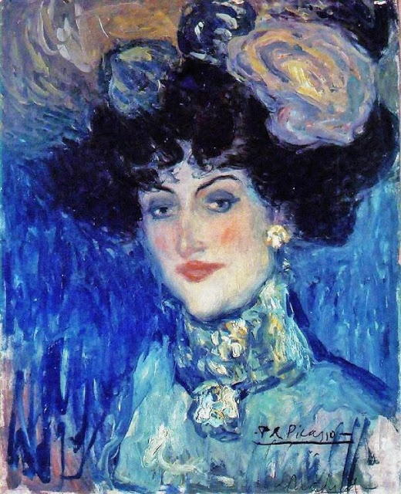

Ernest Ludwig Kirchner
Portrait of Hans Frisch, ca. 1907
Kirchner's portrait of his good friend Hans Frisch shows the Dresden poet seated on a sofa. His legs are tucked up under him, with his right hand resting on his calf, while his left hand holds a cigar or cigarette to his mouth. His suit is painted in blues and blacks, with bright pink outlines and under-painting. The cushions and forms of the sofa are painted in yellow, as are his hand and face, with splashes of red, blue and green. The area behind the sofa on the left is painted in dark blue with two muddy colored stripes with red dots. On the right above his head and in the center are the green leaves of a plant; the leaves on the right are outlined in red and highlighted with blue. The paint surface indicates Kirchner used not only a brush, but also thick oil colors squeezed from the tube or spread on with a palette knife. It is, perhaps, the most thickly painted of Kirchner's canvases.

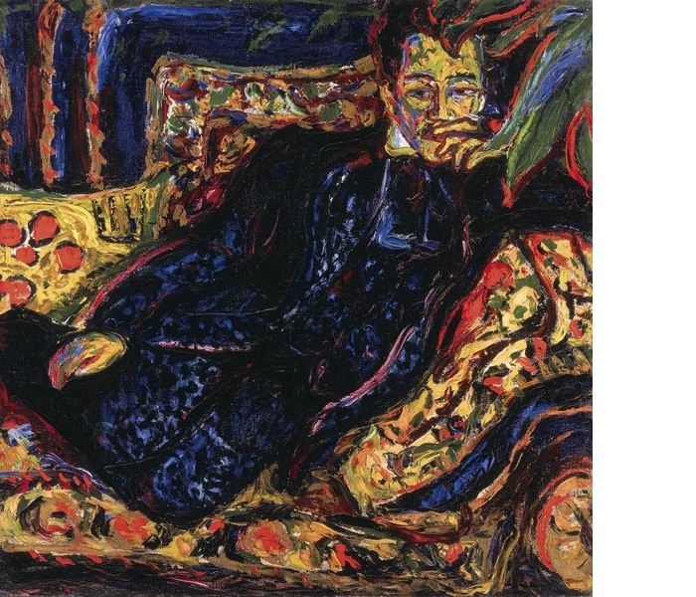

Henri Matisse
The Red Blouse, 1936
Lydia Delektorskaya sits in a black armchair, wearing a brown skirt, a ruffled red blouse, a necklace, a bracelet, and a watch. Behind the chair is a mirror that reflects the back of the chair and the face of the artist, Matisse, who was painting her portrait. The lines of Lydia’s face attest to Matisse’s skill in capturing a likeness through the simplest drawing. Matisse’s green beard, mauve glasses, and bright pink shirt are reminders of his experiments with flat, vibrant colors in 1905-07. Because his colors seemed garish at the time, critics called them Fauve, which means “wild beast” in French. Delektorskaya became the artist’s model, assistant, and companion. Born in Siberia, she lost her parents in the typhoid and cholera epidemcs of the 1920s. She arrived in France as a refugee, alone, not knowing a word of French. The young Russian modeled for Matisse in 1932. In 1933, she served as a nurse and companion for his wife; she remained with Matisse after his separation from his wife until his death in 1954.

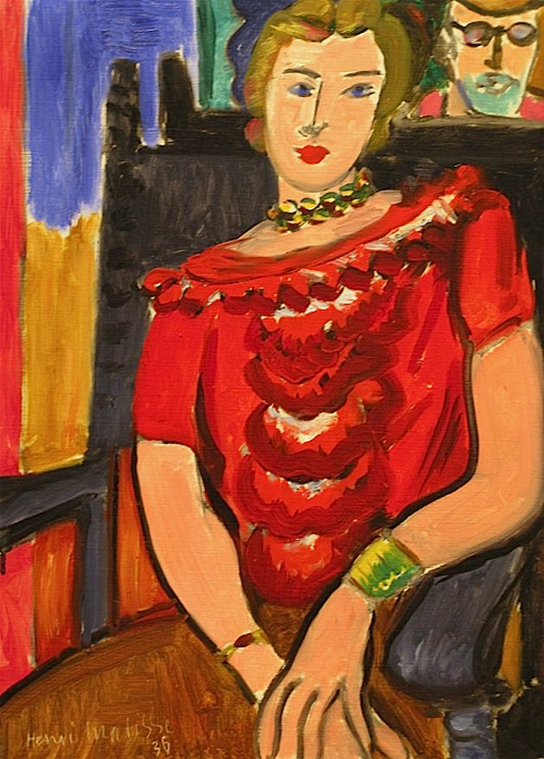

Pablo Picasso
Portrait of Sylvette, 1954
In this portrait, 21-year-old Sylvette sits quietly in a rocking chair with her hands in her lap. In the spring of 1954, Picasso made 40 drawings and paintings of Sylvette David, the beautiful, blonde daughter of a Paris art dealer. She came to the south of France to visit her fiancé, who lived and worked across the road from the 74-year-old artist's house. A few of Picasso's images of her were realistic and in color. Picasso painted the portrait in a style related to the analytic phase of Cubism (1909–1912), with a fragmented geometric composition in restrained colors. The last of his painted portraits of her was the most realistic. He also made Cubist-inspired sculptures of Sylvette. To see other Picasso paintings of Sylvette David, log on to http://www.tamu.edu/mocl/picasso/gallery/w54.html.
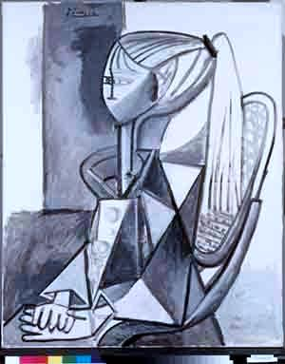
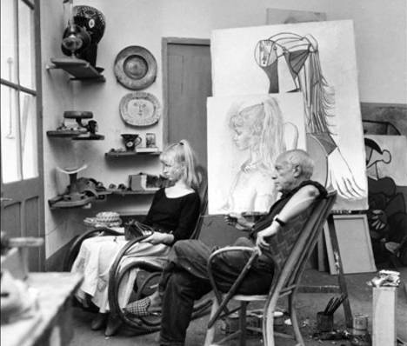

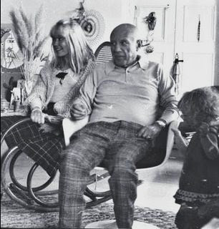

Ben Shahn
Sing Sorrow, 1946
Subdued colors combined with the guitar player's expression and gesture give this painting a melancholy tone. The high-tension wires and a blinking railroad signal hint that the setting is a railroad crossing. Sing Sorrow expresses the grief many Americans felt following the death of President Franklin Delano Roosevelt in April of 1945. The guitar player mourns as the train carrying the President's casket passes through on its way to Roosevelt's burial site in Hyde Park, New York. Ben Shahn made a drawing of a man with a banjo watching the funeral train, and later translated the drawing into this painting. Throughout Shahn's career, his main emphasis was on social and political issues reflecting class struggle and hardship. As a painter, photographer, illustrator, writer, and teacher, he presented compelling images in paintings, murals, prints, and posters, and allowed viewers to formulate their own conclusions and opinions.
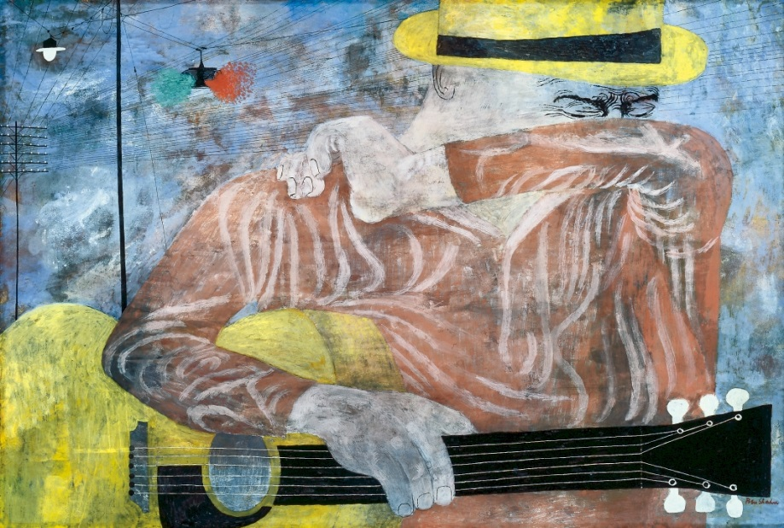

Natalia Gontcharova
Spanish Dancer, 1916
Moved by Spain's rich visual traditions on a visit in 1916, the Russian artist Natalia Gontcharova was enthralled by Spanish women in their magnificent mantillas. Espagnoles, or Spanish dancers, inspired about a dozen works by Gontcharova. Some of her Espagnoles are more figurative than others, but all are similarly stylized, abstract presentations. A diligent artist for whom preparation and research played an integral part, Gontcharova produced designs for two Spanish ballets, although
neither was ever staged. In her collage shown, twisted paper and overlapping materials show the sculptural qualities created when a dancer's movements animate her costume, and evoke feelings of lively passion and movement.

