Drawing 1/2

Mrs. Heather Swader
North High School
812-435-8888, ext. 42150
heather.swader@evsc.k12.in.us
http://swaderart.weebly.com
Twitter - @HeatherSwader
Instagram - @nhsart

Course Description:
Drawing 1 and 2 are studio drawing courses with emphasis on learning to see and developing basic drawing skills using various media by employing fundamental design and composition concepts. In addition to technical skills, an exploration of creative thinking, problem solving, and critical analysis will be studied. During the semester, students will explore different drawing techniques and media. Students will be encouraged to develop an expression of individual style.

Drawing I offers an in-depth opportunity to develop skills, explore personal expression, and research possible solutions in a variety of techniques and media. Drawing II is a continuation of Drawing I providing an opportunity to further refine personal expression and research creative solutions in a variety of media (colored pencil, soft pastel, watercolor, etc).

Purpose:
This is a hands on art class in which you will be exposed to the principles of drawing. We will work from observation in order to translate three-dimensional objects and space onto a two-dimensional surface. Drawing is a way of seeing that should be developed in an increasingly personal way as the student works through the semester.

Student Learning Outcomes
Students will develop skills to render a value drawing.
Students will understand and incorporate design and composition theories.
Students will be able to analyze a work of art.
Students will understand spatial organization.
Students will experience a variety of traditional drawing materials.
Students will develop a drawing vocabulary.
Students will be introduced to traditional and contemporary artist works.
Students will have confidence in their ability to draw.
Students will learn creative thinking, problem solving, and critical analysis skills.
Students will be encouraged to develop an expression of individual art.

Instructional Activities:
Demonstrations, discussions, lectures, presentations, peer interaction, studio assignments, reading and writing assignments

The Shared Studio:
Students are expected to clean up and store all personal belongings at the end of each class period. Clean-up is extremely important, as the drawing studio is a community space that is in constant use.

Materials: You will only need a pencil (no mechanical pencils), eraser, and your creative mind.

Grading:
Your grade in art will come from the following:
Doing what is assigned and meeting the objectives of the project.
Your finished piece of work
Originality of your work
Being neat and careful
Using your class time wisely
Going above and beyond the project assigned (creativity)
Using your ability to the fullest.
Grading Scale
A | 90-100%
B | 80-89%
C | 70-79%
D | 60-69%
F | 59% and below

Overall Semester Grade Breakdown
Formal Art Projects | 60%
Reading and Writing Assignments | 20%
Quick Practice Assignments | 15%
Critiques | 5%

Class Work & Homework Expectations:
Students will be expected to finish their art projects in class. Art projects are created best at
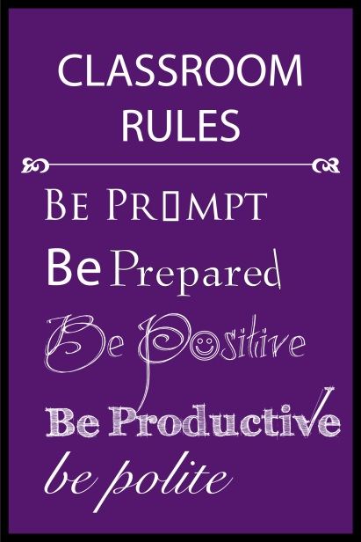
school where students have access to all materials. However, if a student is falling behind on assignments they always have the option of coming into work on their projects during homeroom or before or after school in my classroom. If a student can’t complete a project at school then they need to come see me to make arrangements to take their projects home.
Students will also be expected to complete occasional reading, writing and practice assignments for homework.

Semester Curriculum:

- Elements and Principles of Art
- Positive/Negative Space
- Picture Plane/Depth of Space
- Value
- Shape/Form
- Perspective
- Portraiture/Figure Drawing
- Grid Drawing
- Color Theory
- Art History

By signing this you state that you have read and understand the rules, procedures, materials policy, and grading policy of Mrs. Swader’s Drawing 1/2 class. Please sign, detach, and return this slip by ___________________.

___________________ ___________________ _________________
Printed Name of Student Student Signature Date

___________________ ___________________ _________________
Printed Name of Parent Parent Signature Date

Parent Phone Number(s): __________________________
__________________________
Parent Email Address(s): __________________________
__________________________

Drawing 1/2 Honor Code
In signing this form I declare that I understand what constitutes PLAGIARISM in this class. Specifically, I agree that all work presented will be my own work and created solely by me, and that the consequences associated with cheating and/or plagiarizing will be an automatic “F” (zero) on that assignment, as well as disciplinary action. Any work that makes use of other artists’ works (including photographs) and/or published images must show substantial and significant development beyond duplication. Doing work for others is also considered cheating and will be treated in the same manner as turning in work that is stolen, copied or plagiarized.

